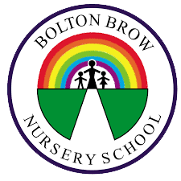
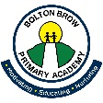
Bolton Brow Primary Academy Yearly PSHE Overview

Unit of Learning | Autumn 1  Reception – Y6 | Autumn 2  Reception – Y6 | Spring 1  Reception – Y6 | Spring 2  Reception – Y6 | Summer 1  Reception – Y6 | Summer 2  Reception – Y6
 | Being Me in my World | Celebrating Difference | Dreams and Goals | Healthy Me | Relationships | Changing Me

