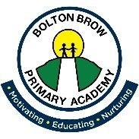

Bolton Brow primary Academy Local Governing Board Meeting Attendance.
2023 – 2024

Name | Meeting Dates
 | 16.10.23 | 22.01.24 | 18.03.24 | 24.06.24
Jo Beardwell | Y | Y
Bob England | Y | Y
Maria Money | Y | Y
Ross Morrison McGill | Y | Y
Kirsty Whitehouse | Y | Y
Emma Holmes | Y | Y
Paul Cuthers | Y | Y
Julie Wolstenholme | Y | Y
Paul Kelesidis | Y | y

Y = present
A = apologies
N – non-attendance without apologies
L – left the governing board.

