Bolton Brow Primary Academy

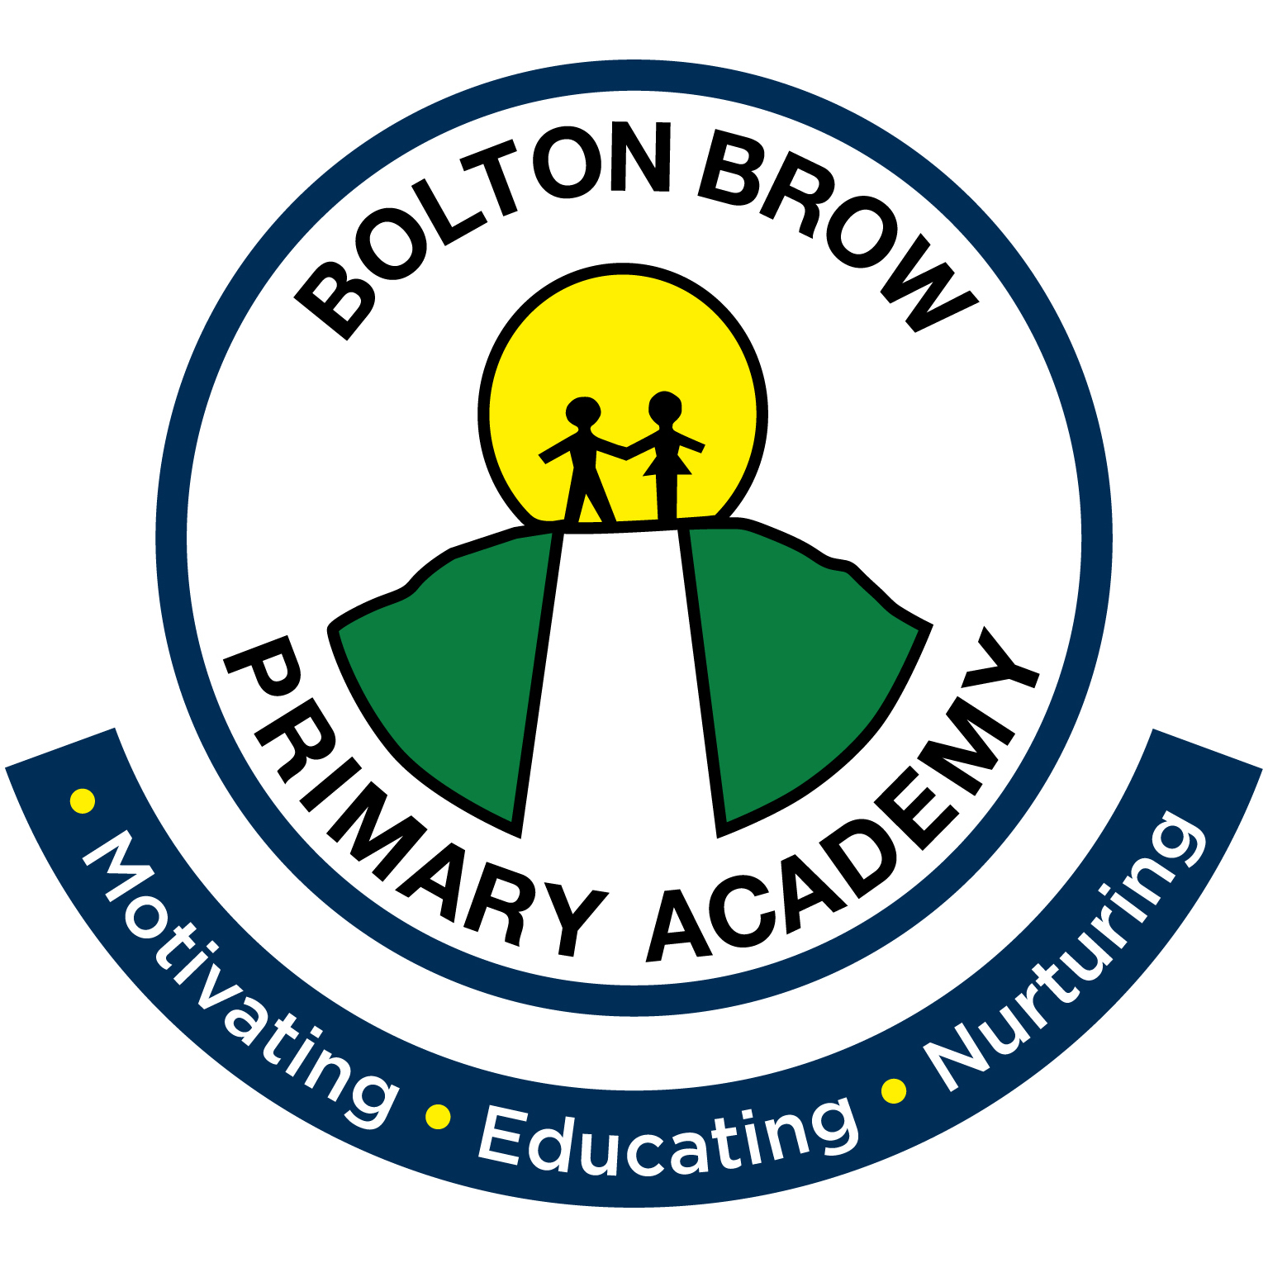

Admissions Policy Nursery

Contents
Statement of intent
- Application timetable
- Over-subscription
- Reserve list
- Withdrawing offers of nursery places
- Admission to reception class
- Refusal of admission
- Additional sessions
- Sickness absence
- Settling in
- Charging policy

Statement of intent
Bolton Brow Primary Academy aims to provide a nursery experience for children that is affordable, high quality and geared towards a smooth transition into primary school.
The Governing Body is the Admission Authority and is responsible for setting the school/setting’s Admission Policy. The policy is written to ensure fairness and equality for all those intending to begin their education at Bolton Brow Primary Academy
This policy follows non-statutory guidance, and the current School Admissions Code does not apply for nurseries and early years settings.
This policy will be reviewed annually.
Bolton Brow Nursery
Bolton Brow Nursery has a nursery number of 26 FTE (full-time equivalent) places. Sessions run ‘term time only’.

Application timetable
  - According to local guidelines, a child is deemed to be of nursery-age from the beginning of the term following their third birthday.
  - Parents may register their interest in a place at Bolton Brow Primary Academy at any time during the year.
  - Formal applications for Nursery must be made prior to the term start.
  - Application information and forms are available from the Academy office.
  - Letters confirming or refusing places will be sent to families before the start of each term.
  - Where places are remaining, later admissions are possible up to the agreed admission limit.
  - Places offered will be available to the child from the date the place is offered until 31 August following their fourth birthday.

Over-subscription
  - Children under statutory assessment of their Education, Health and Care Needs or with an Education, Health and Care Plan (which names the school);
  - Children in Public Care (Children who are Looked After), including those who have been adopted or who are subject to a residence order, a special guardianship order; or a child arrangements order.
2.3 Children who have a sibling attending the school at the time of admission (Siblings are defined as children with brothers or sisters (including half/step-brothers or sisters) permanently resident in the same household, in attendance at the same school or a school on the same site, on the date of admission);
2.4 Other children.
If there is over subscription in any category, then children should be admitted in the order of proximity of the pupil’s permanent home to school. Distance should be calculated using a straight line measurement from the pupil’s home to the closest designated school gate. Distances should be calculated using the Local Authority’s GIS (Geographical Information System). No other method of measuring distance will be considered. Each property has a co-ordinate taken from Ordnance Survey ADDRESS-POINT data. This is the point from which distance measurements will be made.
Parents/carers must inform the school immediately of any change of circumstances that may affect their application (for example, a change of address.)

Reserve list
  - In circumstances where more applications are received than places available, and where the oversubscription priority criteria has been applied, children who are not offered places will be added to a reserve list in order of the criteria and not by date of application.
  - If a place becomes available, the nursery will contact the parents of the child at the top of the list.

The reserve list should not be considered a “waiting list”; if a request is made by a parent whose child has higher priority according to the admission criteria, other children will be moved down the list.

Withdrawing offers of nursery places
  - Once an offer has been made in writing, there are limited circumstances in which a nursery may withdraw the offer including:
- Offers made on the basis of fraudulent applications.
- Offers made on the basis of intentionally misleading applications.
- Where a parent has not responded to an offer within a reasonable time (the start of the final week of the term before the child is due to take up the place).
- Where a child is in receipt of more than their entitlement of nursery education.
- Where a family registers their child at two maintained settings.
- Where a child fails to take up their place up to 2 weeks after the agreed start date.

Admission to Reception class

Parents/carers should note that admission to Bolton Brow Nursery does not guarantee an automatic place in Reception at Bolton Brow Primary Academy. A child’s attendance at a school nursery will be taken into consideration in line with the oversubscription criteria outlined in the school admission policy. All parents of children in nursery classes must complete a Schools’ ‘Common Application Form’ on line in order to request a full-time place in school. More information on the admissions process is available at http://www.calderdale.gov.uk/education/schools/admissions/index.html
  - Children reach compulsory school age as follows:
    - Children turning 5 years old between 1st January and 31st March are of compulsory school age at the beginning of the term after 1st April.
    - Children turning 5 years old between 1st April and 31st August are of compulsory school age from the beginning of the term after 1st September.
    - Children turning 5 years old between 1st September and 31st December are of compulsory school age from the beginning of the term after 1st January.
  - Parents have the choice of how and when their child starts reception class until they reach their compulsory school age.
  - If parents wish for their child to remain in a nursery or early years setting until they reach compulsory school age, and access 15 hours of free early learning rather than taking up a place in reception, they must:
    - Discuss their choice with the school/setting in the first instance.
    - Complete an online Reception Application Form for their child, to ensure their child has an offer of a place in Reception from the following September in case they cannot be re-admitted.
    - Complete a Nursery re-admission application form and return it to the setting.
    - If they are offered a re-admission to the school/setting, notify the school that their child is due to attend in September of their arrangements, and discuss with them the future arrangements for the admission of their child.

Refusal of admission
  - A child may be refused admission only if:
    - The nursery has reached the admissions limit.
    - Τhe child is not of the appropriate age.
  - The strict statutory criteria governing adult : pupil ratios mean that it is not possible to appeal against the admission authority’s refusal to award a place at a nursery provision
  - There is no right to appeal the Admission Team’s decision not to award a place where the provision in question is not named in the EHC and the Early Years team has determined that other provision is suitable.
  - Parents may appeal to the SEND Tribunal against the provision named by the Authority in the EHC.

Additional sessions

The current entitlement to 15 hours or 30 hours of funding can be utilised flexibly as long as there are spaces available in the sessions requested. If there are sessions where the number on roll is less than 26 children these surplus places will be offered for an additional fee.
7.2 Bolton Brow Nursery offers additional lunchtime sessions to children. These are offered at an additional cost.

Sickness absence
  - Where a child experiences long-term sickness (of less than a half term’s duration) the nursery may keep open the place and retain nursery education grant for the child.
  - If the illness continues but the parent and nursery intend the child to return subsequently then Early Years Education Funding may be claimed in good faith.

Settling in
  - The settling in period should be completed by the end of the first half-term.

Charging policy
10.1 Parents/carers are not required to pay a fee for their child’s free entitlement to early years provision nor expected to take up or pay for any additional services as a condition of a pupil attending a free nursery education place.
Bolton Brow Primary Academy will provide parents/carers with clear written information about any fees or charges for optional additional services on request.
The current charges are set out in Appendix 1 of this policy.

Attendance/ absent management
11.1 Bolton Brow Nursery works to a ‘provider agreement’ with Calderdale Council. This agreement links attendance to funded hours within the provision. Bolton Brow Nursery will follow the guidance set out in Calderdale Council’s ‘Attendance/ Absence Management Policy’ which is set out in the appendices of this annual funding agreement. This is attached to this policy (Appendix 3). Parents/carers will be made aware that unsatisfactory attendance at the Nursery could lead to funding been withdrawn.
11.2 Bolton Brow Nursery follows the attendance policy set out by Bolton Brow Primary Academy (Appendix 2). This states that parents/carers must contact the academy office on the first day of absence stating the reason for the absence and when the child will next attend a Nursery session. Parents/carers will be expected to provide a letter and/or evidence of medical appointments attended during the Nursery session(s).
11.3 Bolton Brow Nursery attendance will be monitored and any unexplained absences will be followed up. The academy office will follow up any unexplained absences on the first day and subsequent days. This may be referred to the Education Welfare Team if the academy feels there is a safeguarding issue.

Appendix 1 – Summary of charges for additional hours as of September 2018.

£12 for each additional session, (morning or afternoon).
£4 per hour for additional childcare.

School lunch - £1.25 per lunch

