Information for Parents and Carers : Google Classroom Guide

Please follow the information below to log on to your child’s Google Classroom Account over the next week and submit the simple task there so that we know you have been able to access the platform.
Although we really hope we won’t be faced with having to move learning online again this year for our children, we have been asked to ensure all our families are prepared with logins and the means to access learning if this was the case. If you have any problems, please pop in and see one of the team or email us.
In Year 1, and throughout KS1 and 2, we use Google Classroom as the platform to help us with online learning. We will use Google Classroom in school as one of the ways to safely access online resources during computing lessons this year. We will also occasionally use Google Classroom to set homework or provide useful links so please do set it up this week.
We will always let you know in advance if we are setting online homework instead of paper homework and for Year 1 this will be when it may be easier for parents to return homework via the platform eg: if the homework involves taking photos, creating a video or presentation.
Thank you in advance,
The Year 1 Team
- Open Google Classroom on your device.
If accessing through a Desktop PC, Mac or laptop, this can be done by clicking on this link https://classroom.google.com or typing it into the search bar on your browser.

If you are using a tablet device or smartphone, you will need to download the Google Classroom app.

If you are using a Chromebook, you will need to download the Google Classroom app from the Web Store.
- Enter your child’s Username & Password
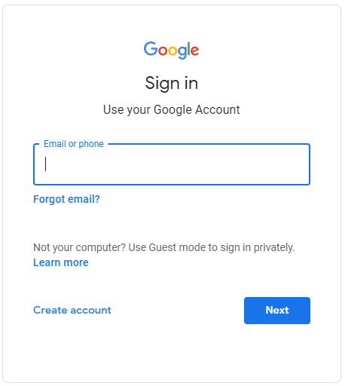
Each child has a unique username and password to log on. Their username is made up of
- their first name
- their last name
- a full stop in-between their first and last name
- @boltonbrow.calderdale.sch.uk

For example for a child called Jane Smith, this would be jane.smith@boltonbrow.calderdale.sch.uk

When you click “Next” there is a box to enter the password.
The Password for all our pupils is Google123.

*Please keep this the same as pupils will learn it and begin to access online resources using Google Classroom during our computing sessions. Only children and staff at Brow have access to resources and learning shared on our platform. *
- Enter our online classroom!
Click on the title that says “Class 1” to enter the virtual Classroom.
The first time you log in you will need to click ‘join’ to join the class
Year 1 Class 1 2021-2022 code: oi462h6 (unlikely to need this code as I have sent invites to all our pupils but just in case!)

Navigation tips:

Stream
This is where your child will see posts from their teachers. Posts may contain links to websites, classwork set by your child’s teacher or any other communication needed.
Classwork
This is where your child will access curriculum content set by the teacher. This is the best way of accessing the content set rather than having to worry about searching on the Stream.

Any curriculum content added will be in the form of a Google Doc, Google Slide or other Google Suite app (If you are using a tablet, you may be required to download additional free apps) as this will allow the children to edit and hand in their work individually to the teacher. Classwork will usually have a due date for completion. Teachers will be able to see your child’s progress and support them where necessary and can add comments to the children’s work. Please do look back at these if work is returned to you.

To complete work.

- Find the work under the classwork tab.
- There sometimes maybe more than one topic/subject e.g. maths, literacy, science etc. This just makes it easier to find the piece of work. Find the subject you need by scrolling.
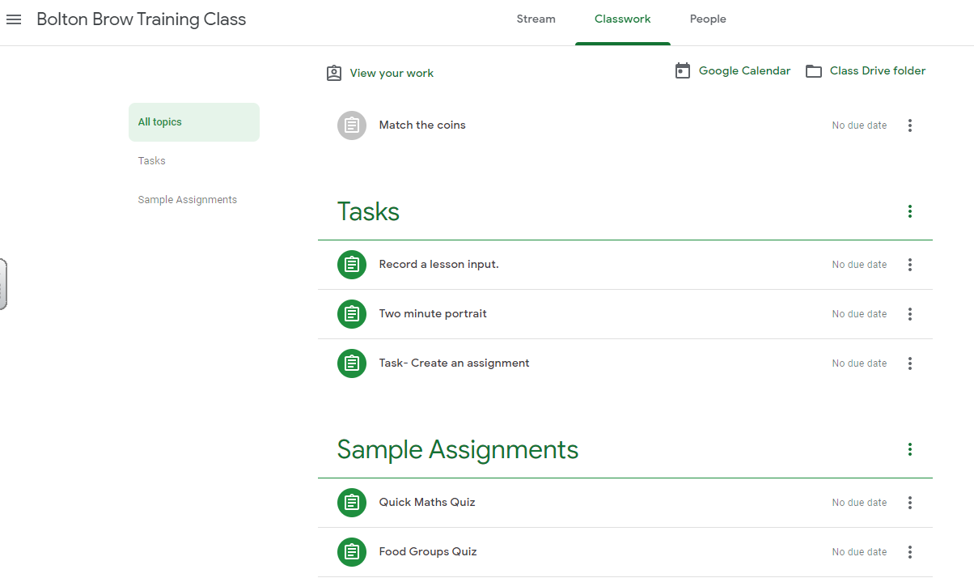
- Children will need to find the lesson they need under that subject and click view assignment. This will take them to a page that looks like this.
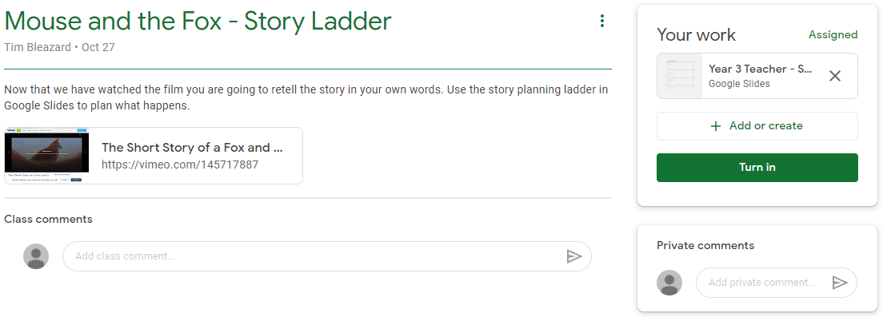
- Any information children need to complete their work will be on the left hand side, and the task / resources will be on this page too. When your child clicks on their work (right hand side), their work will open in a separate tab (If you are using a tablet, you may be required to download additional free apps).

- If your child has any questions about the work they can use the private message function to speak to their teacher.

- Once your child has completed their work, they can close the tab as it automatically saves.

- If your child would like to add a photo of work set, they can do so by using the ‘add or create’ button (in your work section, on the right hand side).

- Your child’s teacher will then mark your work and may give you a comment. They can also add comments to their work and send it back to support them. Your child may then need to follow the steps above to edit and improve their work.

Video Tutorial (PC / MacBook / Chromebook): https://www.youtube.com/watch?v=ezxg_h4TzUw&feature=youtu.be&safe=true
Video Tutorial (Tablet / Mobile Devices): https://www.youtube.com/watch?v=0v7DuPoh2oc&feature=youtu.be&safe=true

